**Introduction:**

This is the third task of my internship of DEN(Digital impoverment network). The task is related to Optimizing Website Performance. It is the Portfolio Website of myself. At the Start my website performance was 83. The Picture is given below as a prove.

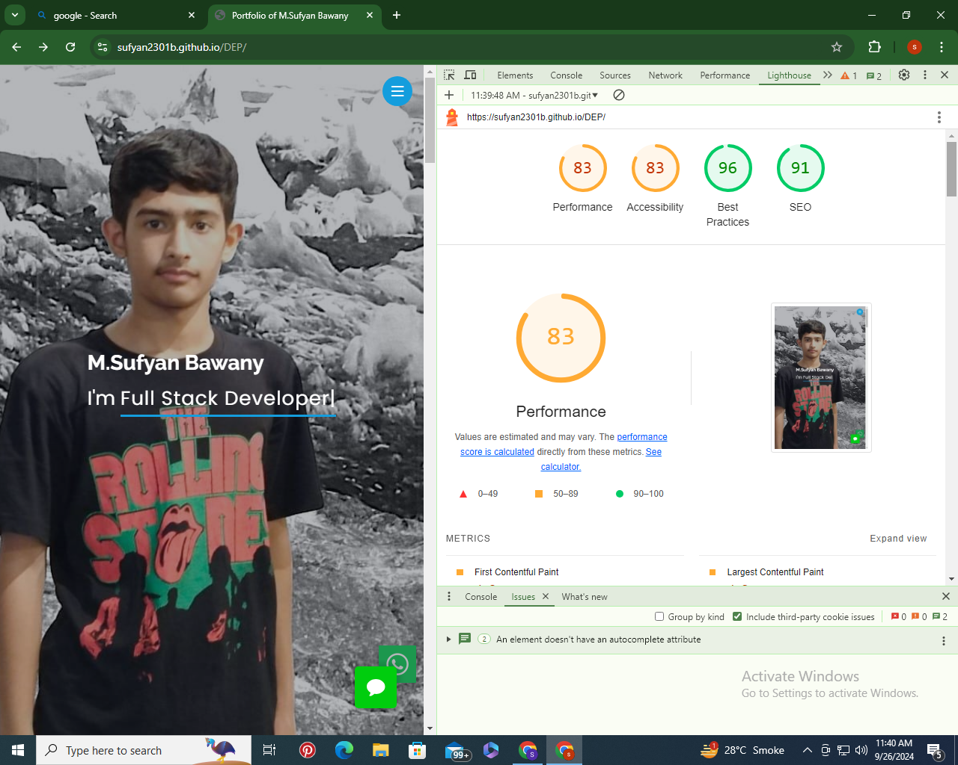

*I boost my website Performance due to these steps:*

* Minimize HTTP Requests by implementing inline CSS.
* Optimize Images by Compressing them using tools like Tiny PNG.
* Implement Lazy Loading by Add **loading="lazy"** attribute to my <img> tags to defer offscreen images.  
    
  *These Three Steps Help me out to boost up my website performance and you can see the image given below as a prove.*

